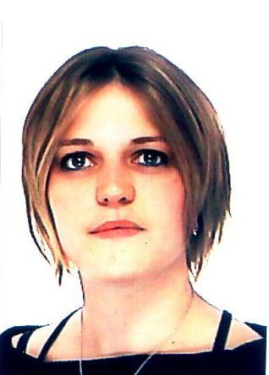
Dheilly Nolwenn
6/33 Nelson St, 2022 Bondi Junction
phone: 04 34 55 25 73
mail : ndheilly@hotmail.fr
date of birth : 01 November 1981

EDUCATION

November 2005: English course, academic 3, 5 weeks (NCELTR, Macquarie University, Sydney)

September 2005: Course-in-residence : High throughput methods of molecular biology in the environmental sciences (Station Biologique in Roscoff, usual language : English)

2005 : Post graduate degree in proteomics (USTL, Lille, France)

2004 : Master’s degree in population biology and marine ecosystems specialization in biodiversity and biochemical analysis, Institut Universitaire Européen de la Mer (UBO, Brest, France)

2003 : Bachelors of science in biology of aquatic organisms, specialization in toxicology (UBO, Brest, France)


INTERNSHIPS

January-March 2006 : Researh assistant (21 hours per week, 12 weeks)
Department of biological sciences, Macquarie University, Sydney, Australia, with Dr. David Raftos and Dr. Sham Nair
Proteomic analysis of hypervariable defensive proteins from sea urchins.

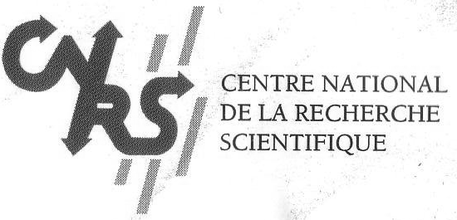
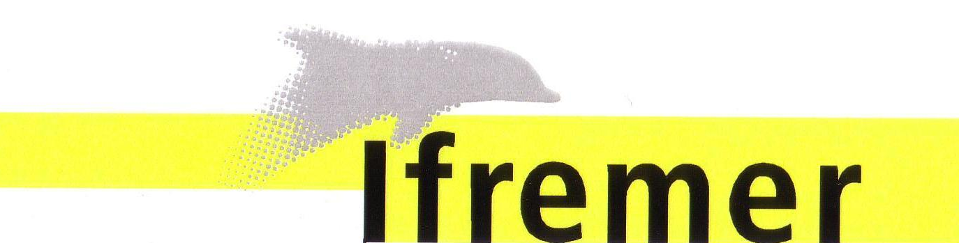
March-October 2005 :
Station biologique in Roscoff, CNRS-UMR 7144, France, with Dr. Franck Zal
Subject : Proteomics approach in comparing enzyme systems involved in oxydative stress response in Paralvinella grasslei.

July-August 2004 :
Station biologique in Roscoff, CNRS-UMR 7144, France, with Dr. Didier jollivet
Subject : Genetic structure of a polychaete (Pectinaria koreni), study of the natural populations from the coast of the Irish Sea and the North Sea.

February-March 2004, August-september 2003, June 2003 :
Laboratoire LEMAR, IUEM, Technopole Plouzané, France, with Dr. Dario Moraga
Subject : Survey of the expression of two genetic markers (HSP and MT) on three populations of oysters (Crassostrea gigas) as a function of exposure to contaminants, and reproductive cycle of the animal.

April- July 2001 :
DEL/PC, IFREMER centre de Brest, France, with Dr. Françoise Quiniou
Subject : Study of the toxicity of sediments enriched in polycyclic aromatic hydrocarbons by the use of a bio-assay bivalve (Crassostrea gigas).

SEMINAR

May 2005 :
Seminar “deep sea hydrothermal vents”, Roscoff, France.
Subject : proteomics approach in oxidative stress response in Paralvinella grasslei

September 2005:
CNRS course-in-residence “High throughput methods of molecular biology in the environmental sciences”, Roscoff, France. Project workshop : “Functional genomics and adaptation”.
Subject : Proteomics and transcriptomics approach in comparing enzyme systems involved in oxidative stress response in Alvinellidae from hydrothermal vents.

ADDITONAL EXPERIENCE

1999-2000 :
Sailing instructor diploma, specialized in Windsurf.

July 2003, July et August 2002, July 2001:
Instructor in windsurf in vacation camp (12-13 years old), near the Azur lake (40, France), organised by the Banque de France.

May-July 2005 :
waitress in a restaurant, pizzeria du port, Roscoff, France.

December 2005 :
Liquor Administration Board approved course in the Responsible Service of Alcohol

FURTHER INFORMATION

licence : driver’s licence
First level of motorboat piloting licence

Language : French
English
Spanish (smattering)
Travels : Australia, England, France, Morocco, Spain, Tunisia, Turkey, United-states.

software : Word, Excel, Internet, Power Point, genetix, genepop, geneclass, image master 2D Platinium and databases : dotplot, sequence alignments, phylogeny, gene predictions, protein annotation, study of 2D and 3D structures.

activities : Windsurf and sailing
diving (20 meters) and spear-fishing
Swimming : High level swimming during 8 years CNB
Drawing, Reading, Paleontology.

