COPYRIGHT MONITORING SURVEY

From Monday the 9th of February through Sunday the 3rd of May the Department of Biological Science will be part of a copyright monitoring survey. This means that we will have to track ALL photocopying done on each of our 6 multifunction devices (4 in E7 and 2 up the hill) for the entire period. In addition all copying for teaching purposes, even if done off campus, is to be tracked

This university copies and communicates copyright material under the educational copying licence in the Copyright Act. Under the educational licence universities are required to provide information about the copying they do so that owners of copyright can be fairly remunerated.

While this is important, as those of you who have authored works used in educational settings will attest, we are working hard to make sure that impact on your day to day activities is kept to a minimum.

What is not being tracked?

Printing, Scanning & Faxing

If you use any of the machines to print a file, scan a document or fax an order you DO NOT need to do anything. None of these activities are being tracked.

What is being tracked?

Hard copy <-> hard copy photocopying. Every time we make a physical copy of a hard copy item we need a record, however, we only need detailed information if the copy is made for teaching purposes. Therefore, we will have reporting in two ways:

1.) If you are making a copy that is not copyrighted or not for teaching purposes you can simply make note on the list attached to the copier. For example, if Lara copied 3 tax invoices for a Non-order Payment Form she would simply note:

Date | Total output pages | Surname
09/02 | 3 | Ainley

No other reporting is required. The survey is ONLY interested in the total number of copied pages and detailed information on hard copy <-> hard copy photocopying for teaching purposes.

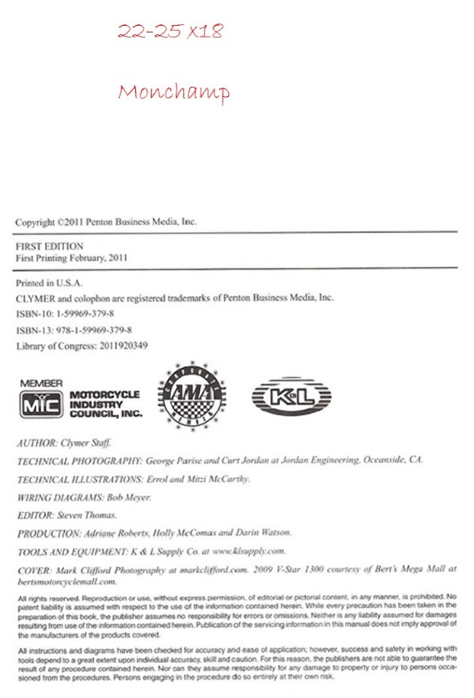
2.) If you do make copies for teaching purposes (wether on campus or off) we ask that you take 1 copy of the cover or title page (preferably including the ISBN) and write on it the page range you copied, the number of copies you made and your last name.

You can leave this page in the folder attached to the multifunction device if printing on campus or drop it into Anne Marie if printing off campus. With this information Anne Marie will fill out all the forms on your behalf.

Please help us to make this survey as accurate as possible. If we do not achieve a satisfactory result we will have to repeat the survey at our own expense.

If you have any questions please contact Anne Marie on extension 6957 or email her at annemarie.monchamp@mq.edu.au

Thank you.

