FREE SEMINAR!!!
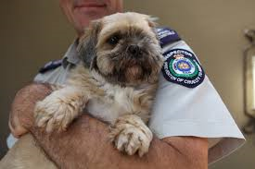
TOPIC: Manage Compliance in the Companion Animal Industry

WHEN: Thursday 19th March 2015
WHERE: W19F Seminar Room
Guest Speakers:
10.15-11.15am: Ian Hughes; Chief Inspector Animal Welfare League of NSW
11.30-12.30pm: Dr Joanne Sillince; CEO Pets Australia
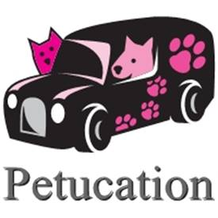
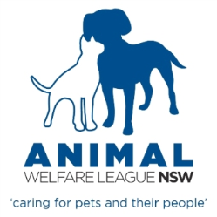
12.40- 1.40pm: Kathy Reidy; Founder Petucation; Lecture: ‘Starting Your Own Pet Industry Business’
