Supervisor Help Card
- Login
- Selecting Application
- View previous comments and recommendations
- Opening Application
- Viewing application Documents
- Example of Providing details and changing status to “verified”
- Returning application with recommendations to DDHDR

- Login
Go to appreview.mq.edu.au
Login with AMIS ID (Not OneID) and password.
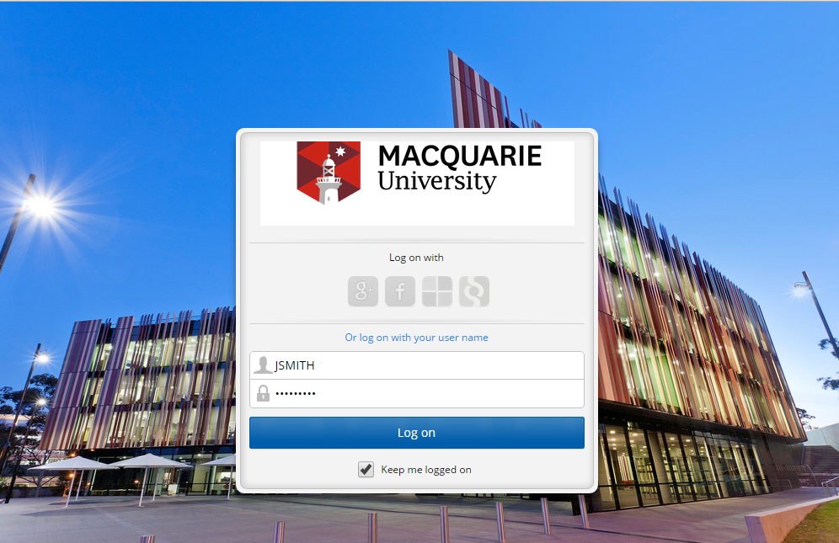

- Selecting Application
Once logged in, click and select “My Workflow Inbox”. This will take you to your Inbox, where all the applications that are assigned directly to you will be visible.
If there is more than 1 application, please select the required application to view its summary on the right hand side.

- View previous comments and recommendations
Once application is selected within the Inbox, scroll down to the “Process View” tab on the right hand side of the screen.
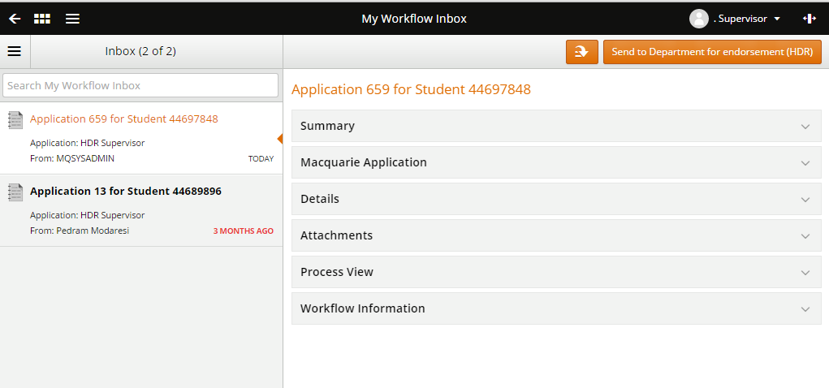
Expand this view to see HDRO’s pre-assessment, Faculty Admin’s and DDHDR’s recommendations and comments.
- Opening Application
Click on the orange arrow and select “open application”
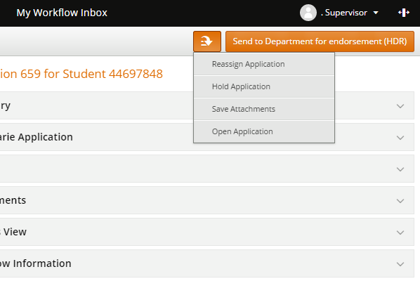
1
2

- Viewing application Documents
On the left bar select “Requirements and Documents”. From here you will be able to see all the documents submitted by the applicant.
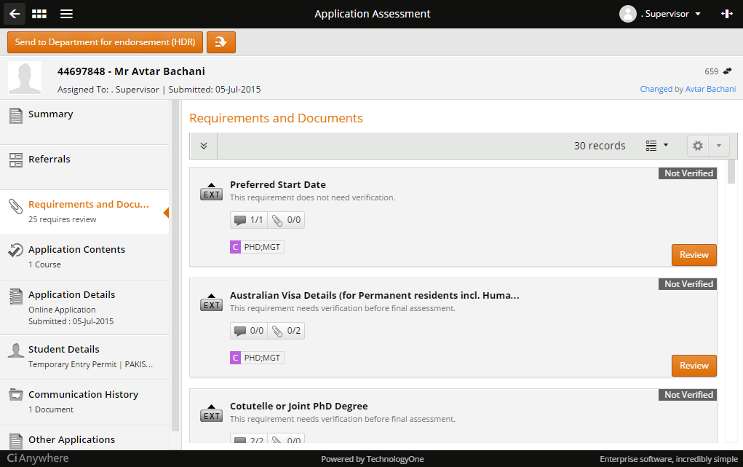
You can view all the requirement and documents as this will assist with your assessment. As the nominated supervisor you will also be required to provide details and/or verify some of these requirements/documents.
Need to Provide details and change status to “verified”:
- Scholarship rating process – Need to complete all required fields and change “Verification Status” to “Verified”
- Approved Thesis Title
- Field of Research Code
- If required, nominate HDRT units, refer to the following URLs
- Confirm approval of supervisor by dept

- Example of Providing details and changing status to “verified”
Select desired requirement/document by clicking on “Review”
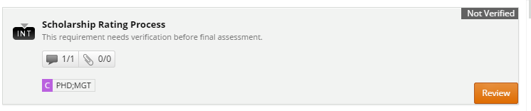
Complete all required fields.
Once all fields are complete, select the drop down from “Verification status” and select “Verified”
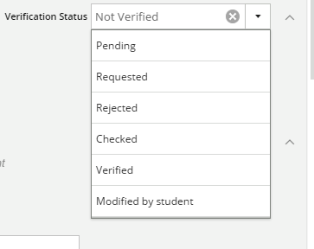
Then select “Save”
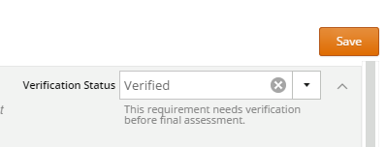
A green saved box will appear in the top right of the page to confirm that your update has been saved.
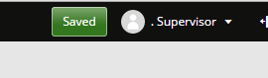

- Returning application with recommendations to DDHDR
Once you have reviewed all the documents, click the orange button on the top left of the screen “Send to Department for Endorsement (HDR)”, This will be the DDHDR of your department.
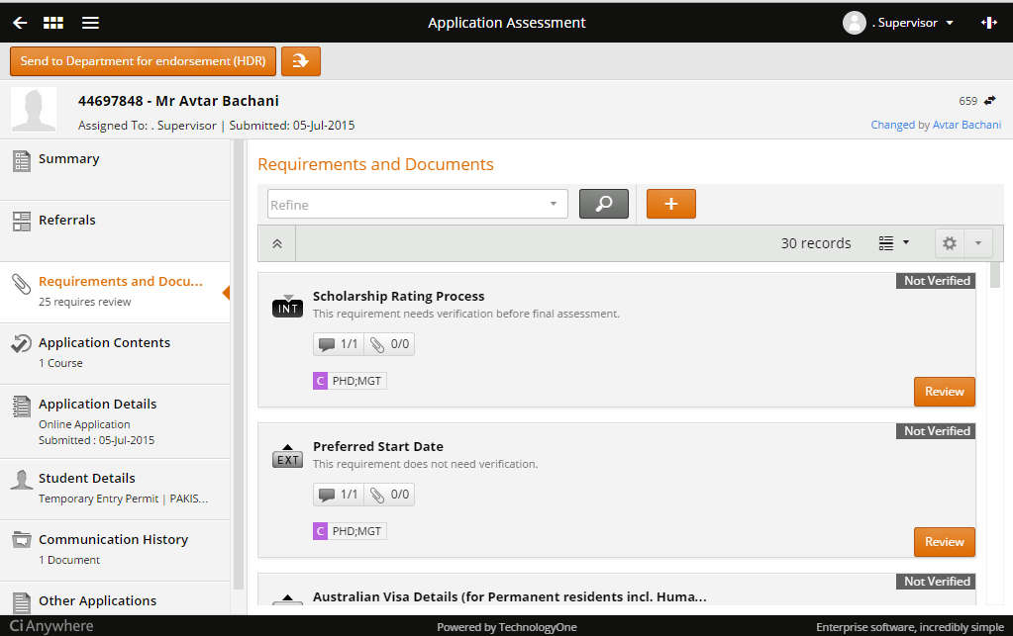
The next step after selecting this option is to enter your recommendation for DDHDR’s endorsement.
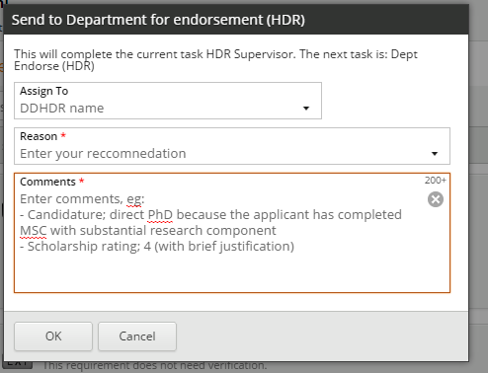
After completing the 3 required fields, click OK. This will forward the application to your DDHDR.

