**Climate Futures/Cooks River Alliance Living Lab Initiative**

**Vision**

To co-establish the first living lab in Australia dedicated to enhancing social interactions with natural systems. The living lab will be a unique and dynamic learning tool that will integrate research and citizen science to educate the community about the interconnectedness of ecological systems in a real-world setting.

**Rationale**

An understanding of science is essential in order for communities to make informed decisions on scientific issues, and yet our basic scientific and numerical literacy is below acceptable standards (Chief Scientist 2013).

Given the complex environmental issues facing today’s society, STEM is crucial to broadening and deepening people’s understanding of scientific issues. Firmly based in the principles of inquiry learning, living labs provide a fully immersive STEM education resource to inspire research and innovation across public and private enterprise. Through the integration of research, education and community engagement Macquarie University can lead a new model of learning, teaching and training, enable experiments across multiple spatial and temporal scales and provide opportunities for students to connect with external partners.

**The Cooks River Alliance**

The Cooks River is 23km long and supplied by a catchment area of 100km2. The Cooks River Alliance represents a partnership of eight councils surrounding this river – Ashfield, Bankstown, Canterbury, City of Sydney, Hurstville, Marrickville, Strathfield and Rockdale. Together, the councils are working with communities to improve the water quality and ecological health of the catchment (Fig. 1).

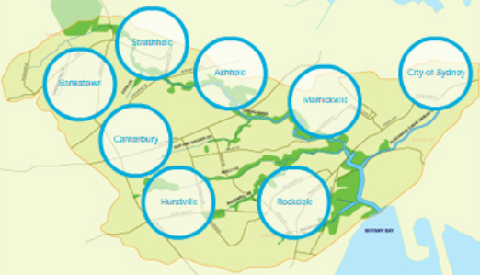

Figure 1. The extent of the Cooks River and the Cooks River Alliance (cooksriver.org.au).

**Climate Futures at Macquarie**

Climate Futures at Macquarie is a multi-disciplinary research centre that engages with government, non-government organisations, industry and the community to develop long-term climate change research projects and educational initiatives.

We will collaborate with the Cooks River Alliance to co-create the first living lab dedicated to enhancing

social interactions with natural systems. Macquarie University will innovate educational processes and conduct learning, teaching and research that is soundly anchored in the University’s Strategic Research Framework and to develop will lifelong and transformative learning through

* Inter-faculty collaboration between Human Sciences (Education) and Science and Engineering. This will ensure the development of fully immersive and integrated educational programs firmly embedded in the K-12 syllabus.
* Programs will incorporate STEM and deliver hands-on activities making students of all abilities and levels, from primary to tertiary, active participants in their own learning.
* Effective training for teachers and private enterprise participants.
* Incorporating indigenous, natural and cultural heritage into materials.
* Highlighting the essential role of Women in Science.

**Proposed disciplines and activities**

A multi-disciplinary approach is needed to broaden and deepen the community’s understanding of the interconnectedness of ecosystems and natural processes. This initiative will bring together researchers from multiple faculties in the university to co-create the Living Lab with the Cooks River Alliance.

Given the diversity of Cooks River ecosystems identified topics include (Fig. 2):

* Climate change – risk, impact, adaptation and mitigation
* Environmental management and health
* Science communication
* Coupled human-nature systems
* Complex biological and ecological systems
* Biodiversity – aquatic and riparian systems
* Evolutionary biology and animal behaviour
* Understanding life on our planet
* Water sensitive urban design
* Education design



Figure 2. Cooks River profile with examples of education potential

**Benefits to stakeholders**

Co-benefits from the establishment of the Macquarie University/Cooks River Alliance Living Lab Initiative include (Fig. 3):



Figure 3. Benefits for stakeholders resulting from Macquarie University/Cooks River Living Lab Initiative.

**How do we get there?**

We have identified several grants that would provide seed funding to begin development of the concept and will be applying for these over the next month. If successful this funding will be used to support the development of the Living Lab.

* **Innovation and Scholarship Program (ISP) Grants:** Closing date 2 April 2015 (Round 1) and 24 August 2015 (Round 2)
* **OEH Environmental Education Grant**: $5,000-$100,000 – Expressions of interest open in March this year.

If you are interested in participating in the co-creation of this initiative please contact

**Daniel Bateman:** daniel.bateman@mq.edu.au

**Leigh Staas:** leigh.staas@mq.edu.au

References: Office of the Chief Scientist (2013) Mathematics, Engineering and Science in the National Interest: A strategic Approach, Australian Government, Canberra.