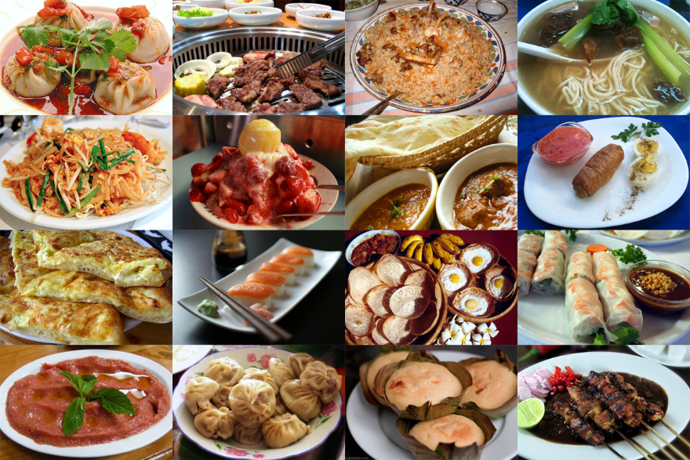
Plastic Free Global Lunch
Thursday 6th June, 12-2pm
Hosted by Biology’s Sustainability Working Group and Diversity and Inclusion Committee

World Environment Day is commemorated each year on 5th June. This year, we’d like to commiserate the bad and celebrate the wonderful aspects of our global environment, while enjoying delicious food from our various cultures.

Plastic Free Lunch
A celebration of cultural diversity, this lunch will showcase food from around the world.
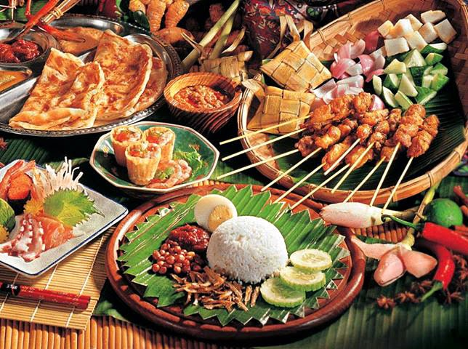
We would like participants to bring a dish to share. The dish should represent your culture or country, or a culture/country you love.
This is a sustainable event, so we ask that no plastic (single use) is included in serving or eating your food. Participants are encouraged to bring their own plates and cutlery. We also encourage people to select, where appropriate, a vegetarian dish.
Here’s a link to a spreadsheet to record what you are planning to bring.
https://docs.google.com/spreadsheets/d/1pPJUN-IZ9xOgtX8zieWiMznzC8Xkn0yzNJmFucNxBWc/edit?usp=sharing

Stories of culture and environment
To encourage sharing and understanding, and to celebrate the planet we all depend on, we are asking you to bring and share environmental stories. From your home, place of birth, or growing up, share two stories. One story that celebrates something amazing about the environment of your home, or the work being done by the community to improve the environment. We also invite you to share a story of environmental crisis. What is having a negative impact on your home?
Email a powerpoint of your story to samantha.newton@mq.edu.au
Stories will be shown during lunch on a screen.
