JOB DESCRIPTION |  | 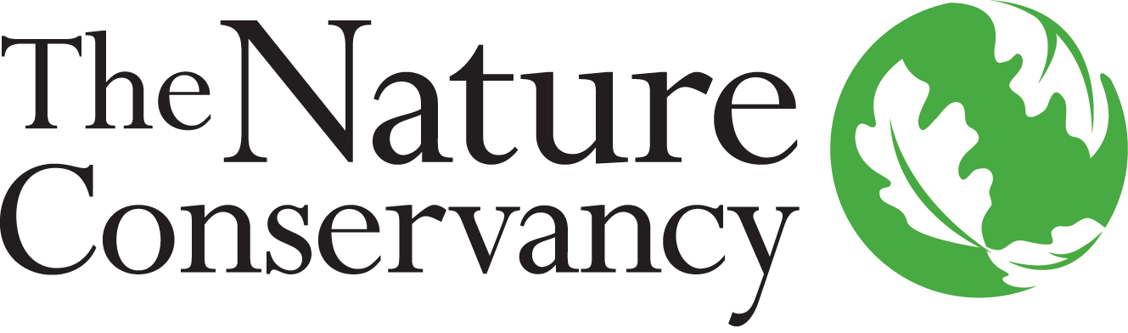
JOB TITLE | Chief Scientist
JOB NUMBER | 49130
LOCATION | Flexible
DATE | October 2020
A LITTLE ABOUT US

Founded in 1951, the Nature Conservancy is a global conservation organization dedicated to conserving the lands and waters on which all life depends. Guided by science, we create innovative, on-the-ground, large-scale solutions to our world's toughest challenges so that nature and people can thrive together. One of our core values is our commitment to diversity. Therefore, we strive for a globally diverse and culturally competent workforce. Working in 72 countries, including all 50 states in the US, we use a collaborative approach that engages local communities, governments, the private sector, and other partners. To learn more, visit www.nature.org or follow @nature_org on Twitter.
YOUR POSITION WITH TNC

The Conservancy seeks a Chief Scientist to provide intellectual and strategic leadership for the world’s largest environmental NGO. As the chief scientific leader and authority for the organization, the Chief Scientist advises senior management on complex aspects of the organization’s two thematic priorities: climate change and healthy land, water and oceans. They mentor the Lead Scientists and Managing Director Global Science and guide the identity and rigor of the science that underpins the organization’s work. The Chief Scientist will be a globally recognized scientific leader and broad thinker with excellent communication skills and a collaborative spirit. They will be expected to serve as an external spokesperson for TNC and have the ability to connect and represent TNC amongst the world’s leading scientific bodies. The Chief Scientist plays a key role in recruiting top science leaders to TNC, building and maintaining partnerships with other scientific and environmental institutions, and guiding the work of the Conservancy’s 300+ scientists. The Chief Scientist is a key thought-partner for the CEO and Board and is a member of the Executive Council.

ESSENTIAL FUNCTIONS

The Chief Scientist ensures that the organization has a strategic science vision for applied science that is aligned with the organization’s outcomes. They offer an inspiring vision for the organization’s mission and serves as a compelling spokesperson for all of TNC’s priority work. They work extensively across global boundaries and collaborates with the external science, conservation and sustainability community and establishes TNC as a global leader in Conservation Science, leveraging partnerships to position the organization to influence policy decisions and scale strategies. The Chief Scientist ensures that the organization adheres to an evidence-based approach. They guide research in support of delivering TNC organizational goals and pushing the organization into new strategic directions as relevant to the Shared Conservation Agenda. The Chief Scientist also contributes to fundraising efforts. They serve on key partnership boards (such as the Science for Nature and People Partnership), and bring world-class scientific advisors in through stewardship of the Science Advisory Council and active leadership on the Conservation Program Committee of TNC’s global Board of Directors.

RESPONSIBILITIES & SCOPE

- Foster risk taking and innovation in order to strengthen the use of science within the organization.
- Articulate vision for how science can accelerate the organization’s mission within the conservation team.
- Advise on rigorous use of evidence and measurement of strategy impact.
- Lead the organizational Science function and have broad mentorship and leadership responsibility for senior level science staff.
- Ensure the development, promotion and implementation of science best practices required to achieve the tangible, lasting results required by the organization.
- Fundraise for conservation and organization-wide programs and projects.
- Serve as a spokesperson for the organization’s work.
- Travel 30% or more throughout the US and internationally.
- May work in variable weather conditions at remote locations, hazardous terrain and/or under physically demanding circumstances.

MINIMUM QUALIFICATIONS

- PhD degree in science-related field plus 10 years related experience in Conservation Science or equivalent.
- Supervisory experience, including motivating, leading, setting objectives and managing performance.
- Global experience in conservation.
- Experience making compelling presentations to a wide variety of audiences.
- Knowledge of current and evolving trends in relevant disciplines.
- Experience in strategic thinking, analytical ability and technical skills.
- Peer-reviewed publications in scientific journals.
- Fundraising experience for conservation programs and projects.
- Experience building partnerships within the scientific community.
- Experience using listening, diplomacy, and tact to build strong relationships and motivate senior managers, donors, partners, staff and volunteers.
- Experience in decision making with legal, financial and reputational results and consequences.

DESIRED QUALIFICATIONS

- Multi-disciplinary thought leader in conservation, with broad global network.
- Reputation for high-integrity, collaborative approach.
- Multi-language skills and multi-cultural or cross-cultural experience.
- Ability to resolve large-scale, complex problems through systematic, thorough studies.
- Ability to propose, implement and manage short- and long-term programmatic goals.
- Ability to lead and/or participate in the formulation of broad, strategic policies.
- Experience in identifying, cultivating and soliciting major donors.
- Proven negotiation and persuasion skills.
- Ability to communicate and deal effectively and tactfully with all levels of management, staff and external parties, including creating and conveying a compelling vision.

HOW TO APPLY

To apply to position number 49130, submit resume (required) and cover letter separately using the upload buttons.

Click “submit” to apply for the position or “save for later” to create a draft application for future submission. Once submitted, applications cannot be revised or edited. Failure to complete required fields may result in your application being disqualified from consideration.

If you experience technical issues, please refer to our applicant user guide or contact applyhelp@tnc.org.

This description is not designed to be a complete list of all duties and responsibilities required for this job.

